Pharmacy multiple payments:-

1. Search for Patient id in HIMS Dashboard. Navigates to patient summary page.
2. Click on "Pharmacy multiple payments" in right side which marked and shown as below.
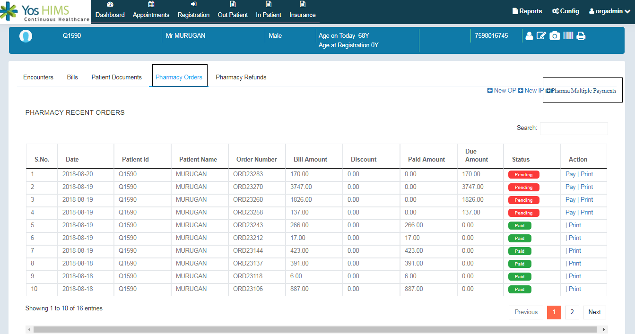
3. Click on Pharma multiple payments, Navigates to create multiple payments page.
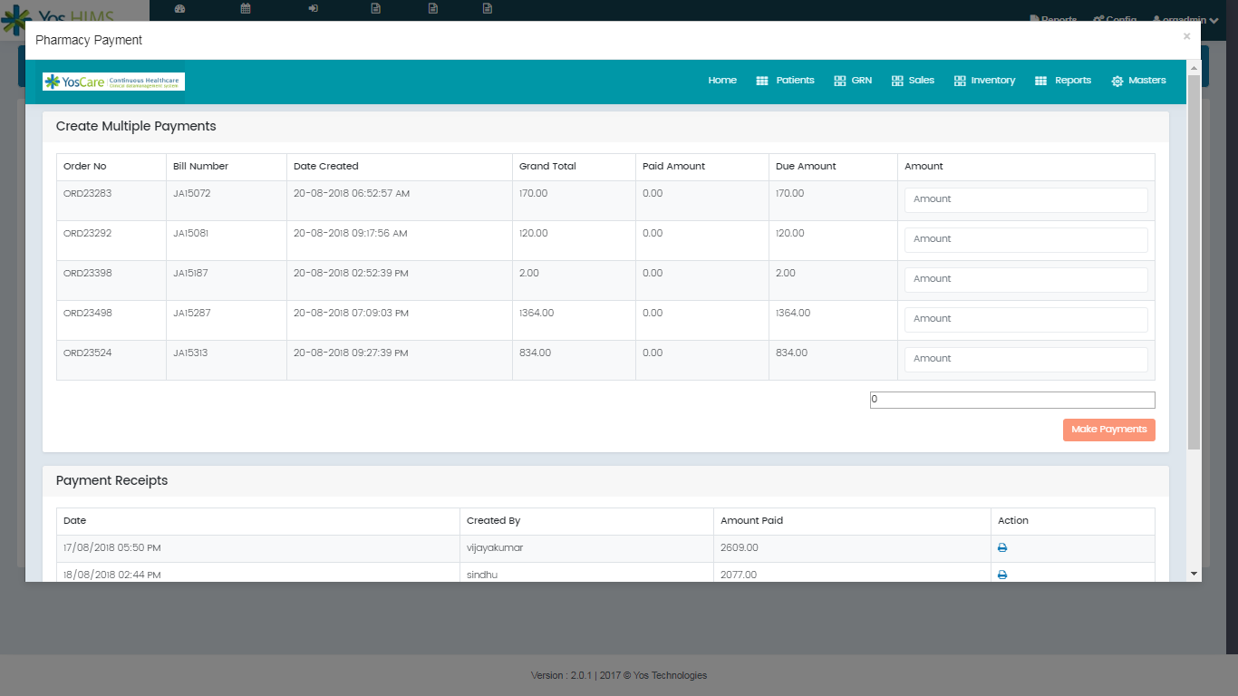
4. Search for Particular order.

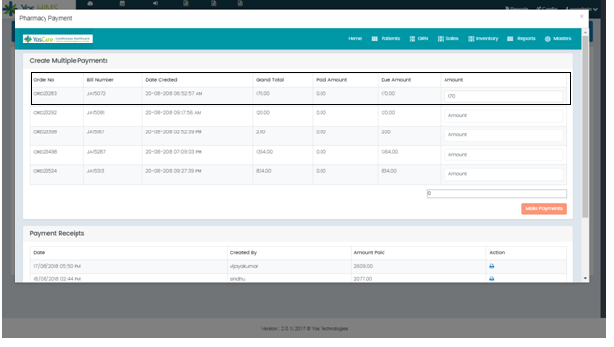
5. Enter the amount and click on " Make payments" button.

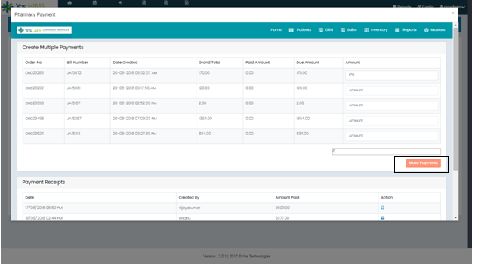

6.click on "Make Payments" button, Shows the "Payment successful" alert message.

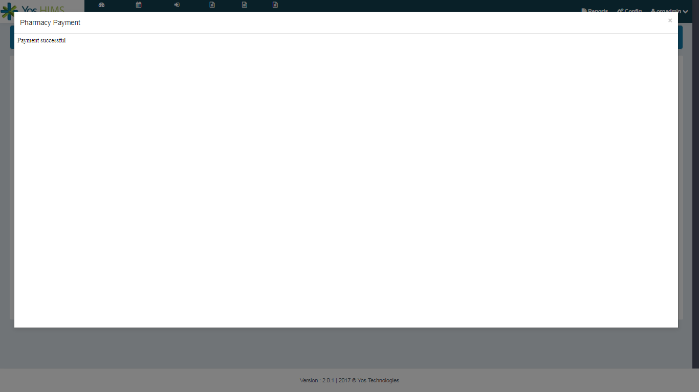

7. The order for multiple payments is shown as below.

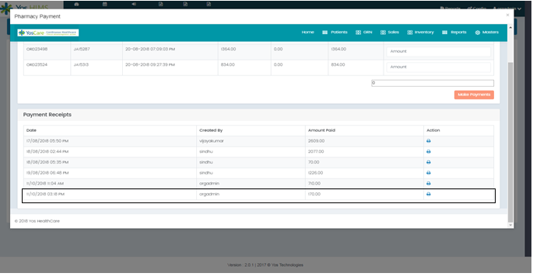

8. Click on print icon. Then the multiple payment receipt will displayed for the specific order.

